**Problem:-**

In this challenge, we test your knowledge of using *if-else* conditional statements to automate decision-making processes. An if-else statement has the following logical flow:

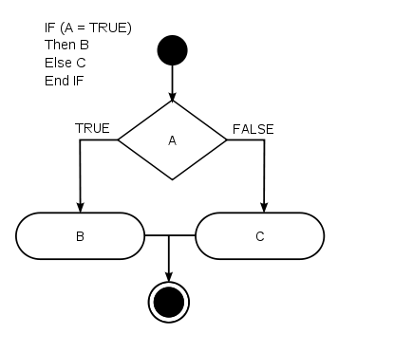

Source:[Wikipedia](https://en.wikipedia.org/wiki/Conditional_%28computer_programming%29)

**Task**  
Given an integer, , perform the following conditional actions:

* If n  is odd, print Weird
* If n is even and in the inclusive range of 2 to 5, print Not Weird
* If n is even and in the inclusive range of 6 to 20, print Weird
* If n is even and greater than 20, print Not Weird

Complete the stub code provided in your editor to print whether or not n is weird.

**Input Format**

A single line containing a positive integer, n.

**Constraints**

* 1<=n<=100

**Output Format**

Print Weird if the number is weird; otherwise, print Not Weird.

**Sample Input 0**

3

**Sample Output 0**

Weird

**Sample Input 1**

24

**Sample Output 1**

Not Weird

**Explanation**

*Sample Case 0:* n = 3  
 n is odd and odd numbers are weird, so we print Weird.

*Sample Case 1:* n = 24  
 n >20 and n  is even, so it isn't weird. Thus, we print Not Weird.

**My Solution:-**

import java.io.*;

import java.math.*;

import java.security.*;

import java.text.*;

import java.util.*;

import java.util.concurrent.*;

import java.util.regex.*;

public class Solution {

private static final Scanner scanner = new Scanner(System.in);

public static void main(String[] args) {

int n = scanner.nextInt();

if(n%2==1 || (n%2==0) && (n>=6 && n<=20) )

{

System.out.println("Weird");

}

else

{

if((n%2==0) && (n>=2 && n<=5) || (n>20))

{

System.out.println("Not Weird");

}

}

scanner.close();

}

}

**Test Case:-**

